**Fleet Safety**

**Practice Manual**

**TSG Australia/NZ**

# What does fleet safety mean to TSG?

TSG has operations and vehicles in all Australian states and throughout New Zealand. This code focuses on what TSG has done and is doing to improve the safety of its road fleet, the drivers of those vehicles and the general public as the TSG vehicles and drivers interact with the general population either on roads or sites.

The TSG operation also includes the Cymix plants and fleet in New Zealand.

Fleet safety to TSG means providing our drivers with properly specified equipment capable of performing the task asked of it, maintaining that equipment to a safe standard and providing drivers and the people that influence them with the necessary knowledge, awareness and training to safely perform their duties and return home safely.

# Heavy Fleet

The TSG heavy vehicle fleet in Australia comprises some 4200 articulated heavy vehicles, 20 tankers and 300 vans. In New Zealand, the fleet includes 278 articulated heavy vehicles 480 tippers and1180 agitators as well as a large fleet of 540 delivery vans and modified cars. The tipper fleet includes rigid trucks, truck and dog combinations, semi-trailers, B doubles and pocket road trains. The agitator fleet includes mini trucks, three axle rigid trucks, 15 axle rigid trucks and semi-trailers.

The TSG fleet includes 4560 company trucks and over 500 contracted owner drivers. This fleet is augmented by use of casual sub-contractors during peak demand.

TSG has 260 concrete plants and 56 quarries in New Zealand with operations on both islands.

Concrete deliveries are made to a wide range of sites ranging from private customers own yards, council work, road construction sites, high rise developments, farms, dam sites to mine sites – including underground mines.

Freight deliveries are made to B2B sites and retail locations around Australia and New Zealand as well as large numbers of B2C deliveries throughout Australia and New Zealand.

The TSG approach to heavy vehicle fleet safety is aligned to the Chain of Responsibility regulations.

# Chain of Responsibility (CoR)

CoR legislation deals with four main areas of road transport:

* Fatigue management,
* Mass, dimension and load restraint,
* Speeding compliance,
* Dangerous goods.

TSG has developed a CoR management manual which deals with the responsibilities and duties of all persons who have a role in the CoR.

We have also been heavily involved in producing guidelines for the industry via the CCAA to raise awareness of the CoR regulations and what minimum actions member companies should be taking.

TSG has recently rolled out a CoR training and awareness program across all operations. In NSW this involved a Compliance Manager visiting each site and training drivers, supervisors, batchers, weighbridge operators, sales loader drivers, pickers and packers, allocators, schedulers, warehouse and site managers on the CoR requirements, their responsibilities and duties. This program highlighted to each person what role they play in the CoR and what responsible steps they must take to ensure compliance. Equally importantly the program also addressed what each of the persons cannot do or what they cannot instruct another person to do.

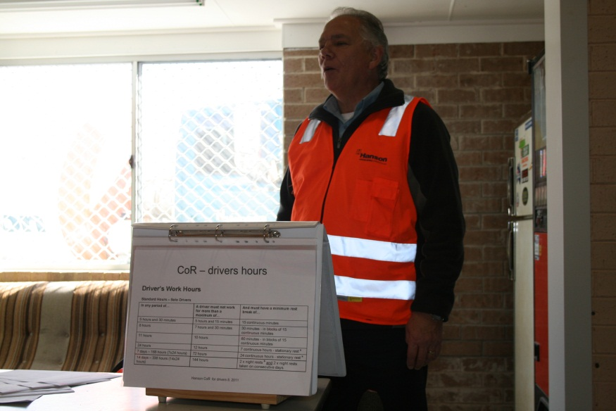

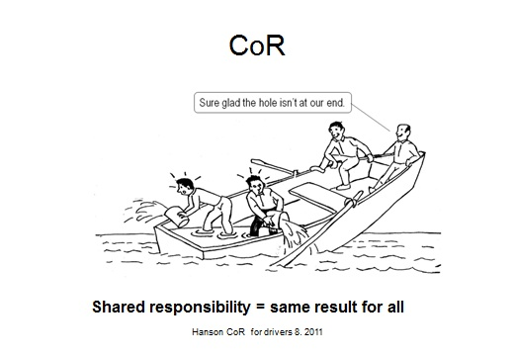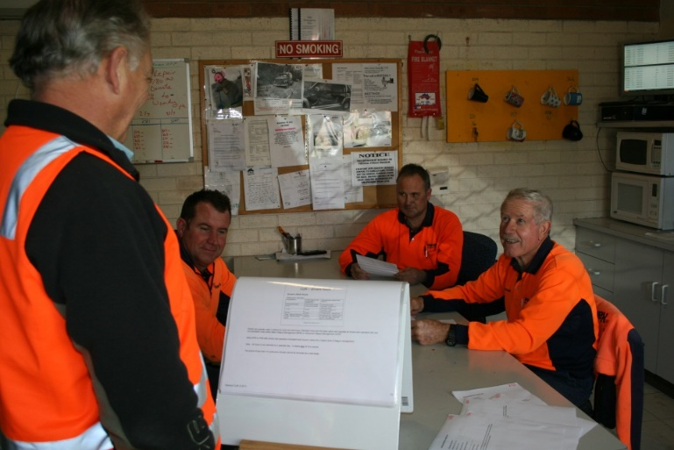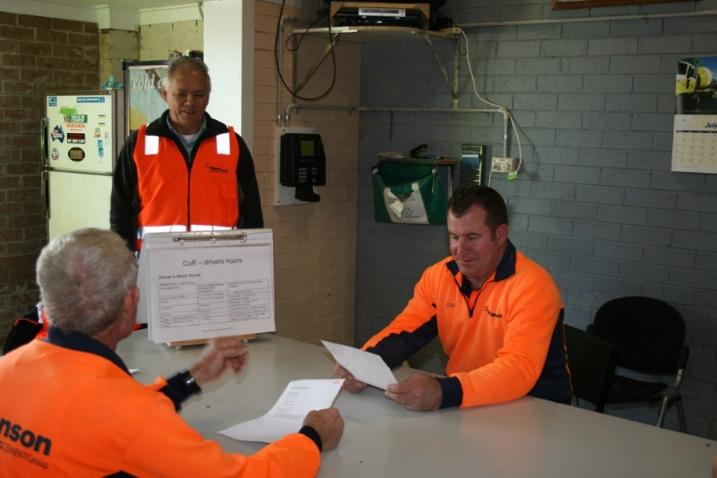

C:\Users\williamss\Documents\chain of responsibility\quarry sign CoR.TIF

*Documentation – TSG CoR Management Manual; TSG CoR for Drivers; TSG CoR for Batchers, Weighbridge Operators and Sales Loader Drivers; TSG CoR for Managers and Supervisors.*

# NHVAS

The National Heavy Vehicle Accreditation Scheme (NHVAS) is a voluntary alternative to conventional heavy vehicle enforcement. Accredited operators must demonstrate that their vehicles and drivers comply with standards set by the NHVAS through regular audits of their transport management systems and vehicle or driver assessments. The NHVAS is intended to increase transport efficiency by reducing the costs of compliance and allowing members greater flexibility in the management of their transport business.   
  
The objectives of the mass and maintenance management modules are to:

* Improve efficiency for scheme members by reducing the impact of conventional regulatory enforcement,
* Raise levels of compliance for non-accredited operators through more effective deployment of enforcement resources,
* Improve road safety,
* Increase the productivity of the transport industry through adoption of 'good' management practices,
* Allow higher mass limits to be introduced in a responsible way.

TSG company trucks based in NT, Queensland, NSW, SA, Victoria and Tasmania are accredited in Mass Management and Maintenance Management with the NSW RMS.

# Maintenance Management

The principle is to ensure that all maintenance of heavy vehicles is to at least the manufacturers’ standards and requirements and that vehicles are regularly checked and all faults rectified.

This module demands nine standards to be met.

1. Daily documentation of roadworthiness checks undertaken,
2. Provision for vehicle fault recording and reporting,
3. Identification, assessment and action on reported vehicle faults,
4. Periodic maintenance schedules with identified service periods that describe all tasks to be completed,
5. Documented evidence maintained to demonstrate the effective operation of Maintenance Management Standards,
6. Clearly defined authority, responsibility and duties of all positions involved in the management, operation, administration, participation and verification of the Maintenance Management System,
7. Internal review to be completed every 12 months to verify that all results and activities comply with the systems policies, procedures and instructions,
8. All persons with a position of responsibility (this includes drivers) are trained in and familiar with the specific policy procedure and instruction they are to carry out,
9. Fuel purchased for use in the vehicle must be obtained from a reputable supplier and measures must be taken to ensure that there is no fuel contamination.

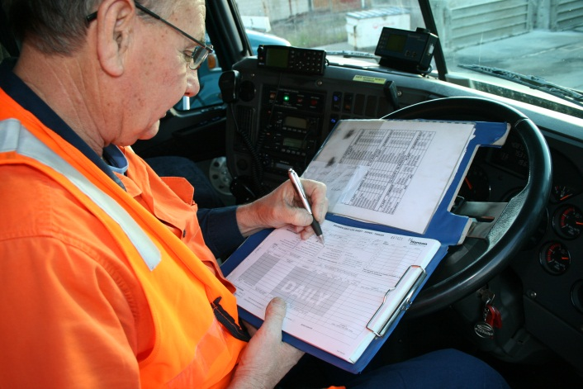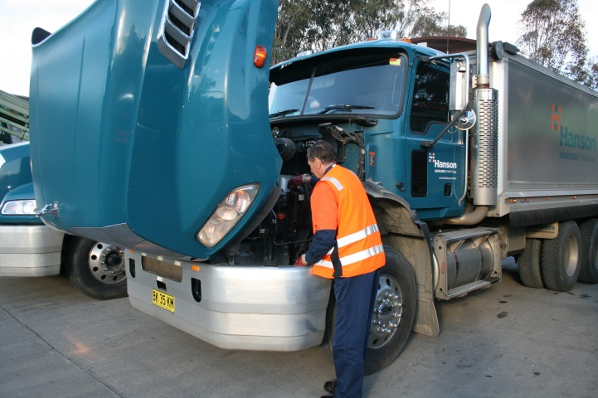

# Mass Management

The principle is to ensure that systems and checks are in place to ensure that all heavy vehicles are loaded up to the legally allowable mass only

This module demands that eight standards be met.

1. Clearly defined authority, responsibility and duties of all positions involved in the management, operation, administration, participation and verification of the Mass Management System,
2. All vehicles nominated by the accredited operator must be operated in accordance with the Mass Management System,
3. Vehicle mass must be determined prior to departure allowing for any variation,
4. Documented evidence must be maintained to demonstrate the effective operation of the Mass Management System,
5. The weight of the vehicle and load must be verified to produce an auditable record,
6. Internal review to be completed every 12 months to verify that all results and activities comply with the systems policies, procedures and instructions,
7. All persons with a position of responsibility (this includes drivers) are trained in and familiar with the specific policy procedure and instruction that they are to carry out,
8. All vehicles subject to accreditation must have their suspension systems maintained and replaced according to Manufacturers’ specification and taking into account the ARTSA Air Suspension Code.



*Documentation – NHVAS TSG Maintenance Management System Manual; NHVAS TSG Mass Management System Manual; NHVAS Driver Training*

# Specification

Heavy vehicles specification has been established and is reviewed regularly by the logistics managers to ensure that the heavy vehicle can perform the allocated task safely and efficiently.

Current tipper and tanker specification includes Front Under-run Protection.

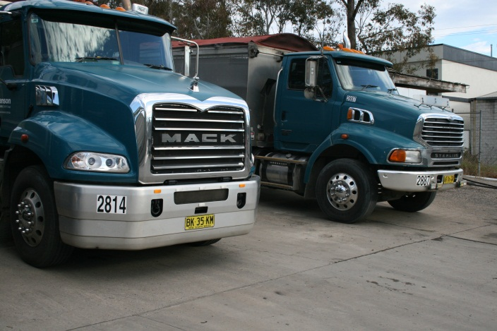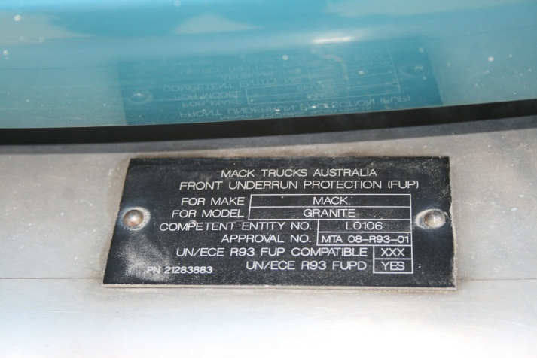

*Truck on left has FUPS front bar FUPS certification plate*

Maxi brake alarms fitted to all heavy vehicles – if driver’s door is opened and maxi brake (park brake) is not applied then horn will sound.

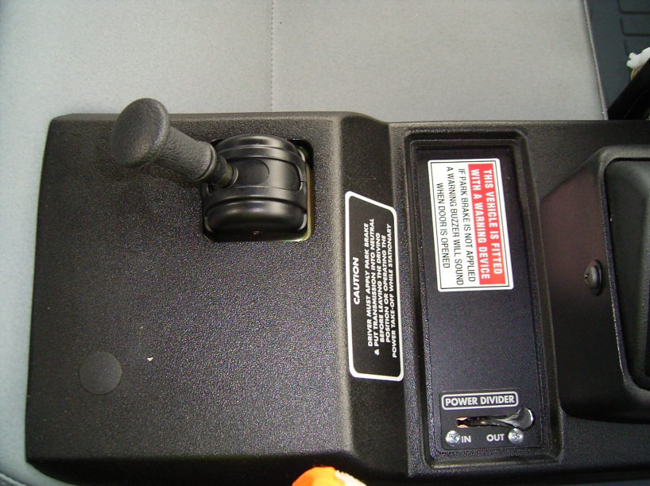

All four axle rigid trucks fitted with maxi brakes to three axles – now adopted by Mack as standard specification.

Rear access steps fitted to agitators. Ladders are deleted option.

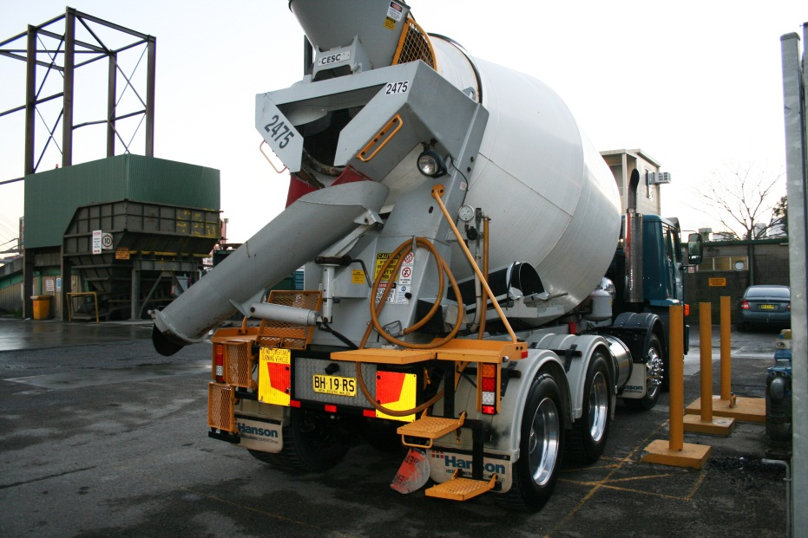

All tippers fitted with motorised tarps and spray suppression brushes.

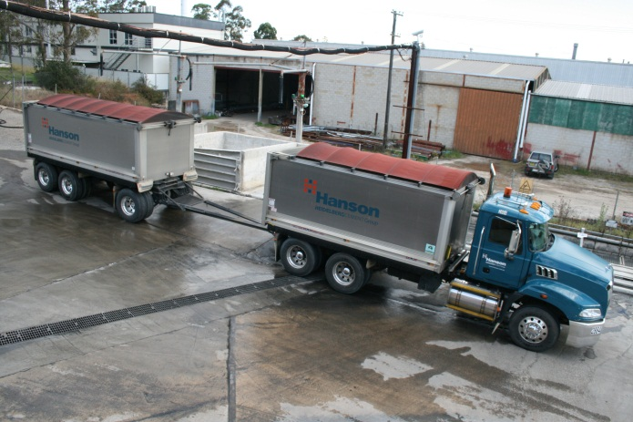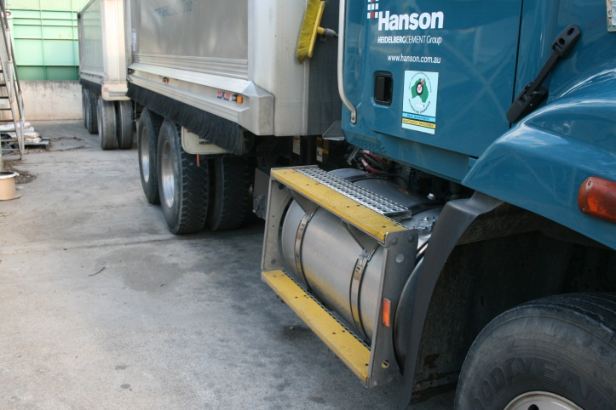

Developing integrated GPS and monitoring system linked to SAP and TeSys (allocation system) to track vehicle location, speed and status and driver’s work and rest hours. Heavy vehicles currently fitted with Tacholink truck logging system.

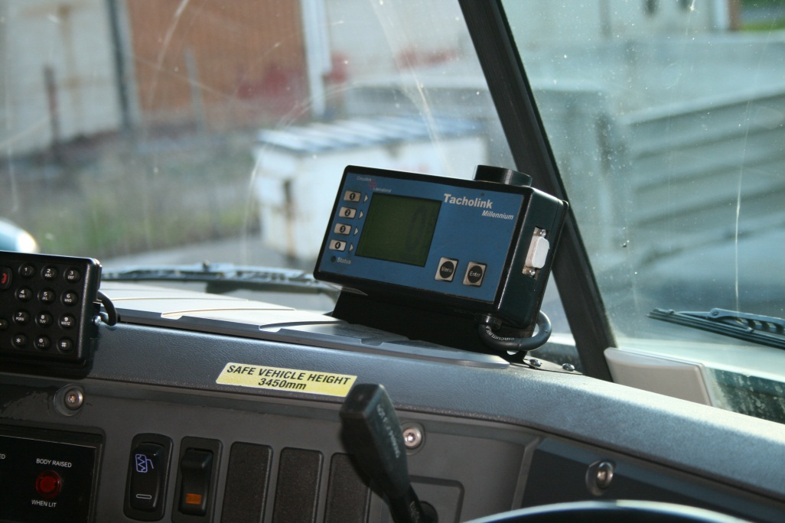

The TSG tipper fleet is one of the few fleets in the industry to specify disc brakes on trucks and trailers.

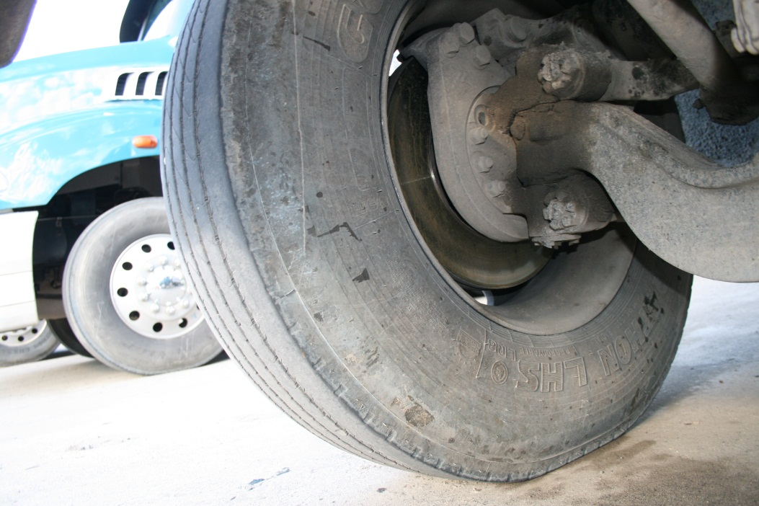

Selection of safety signage and messages.

## 

 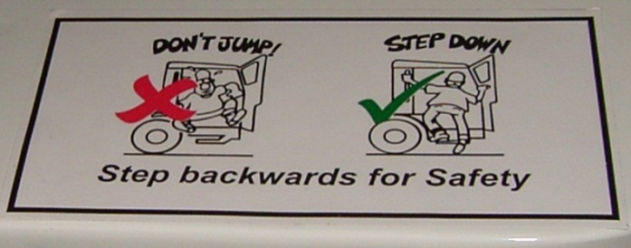

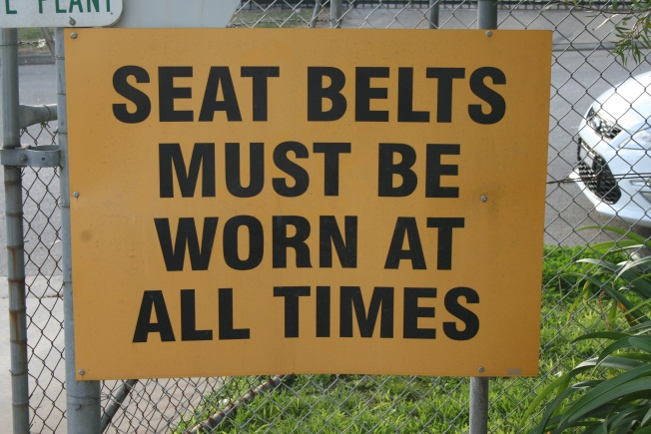 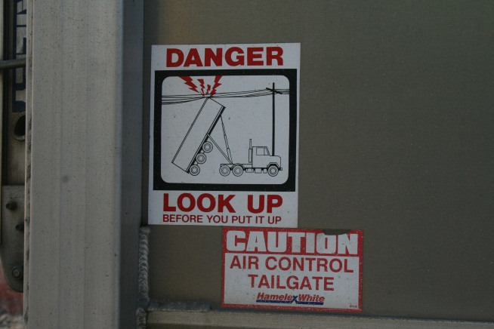

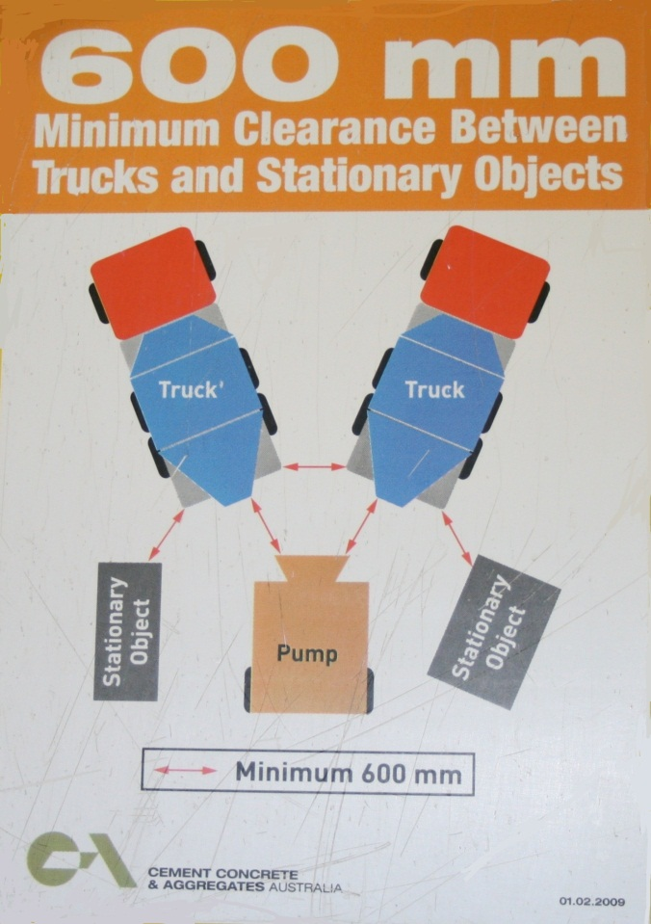

# *Drivers*

# Selection

Driver applicants must pass a pre-employment driving test conducted. Drivers must be medically fit as per the Standards for a Commercial Heavy Vehicle Driver. All employees undergo random drug and Alcohol testing as per the Fitness for Duty Program.

Drivers must possess a current Australian licence for the class of vehicle that they operate.

*Documentation – TSG pre-employment driving test; TSG Fitness for Duty Program*

# Training

New drivers undergo training on the job with experienced drivers before being allocated a vehicle.

In conjunction with the CCAA, an industry standard approach to driver training is being developed. An industry standard set of modules and competencies are being developed for inclusion in a Certificate III course outline.

Drivers must be deemed competent for each type of vehicle that they drive. A driver wishing to move to a larger truck must undertake training and demonstrate competency in the operation of that vehicle before he or she is assigned to that class of vehicle.

*Documentation – Concrete Truck Driver Training Program*

# Assessment

Drivers are assessed annually by their direct manager – topics include driver attitude to road safety and safety initiatives.

*Documentation – TSG Driver development review; Agitator Driver Assessment*

# *Light Vehicles*

The TSG light vehicle fleet comprises some 340 passenger vehicles, 310 utes both 2WD and 4WD, 56 4WD wagons and five light trucks.

The light vehicle fleet is also spread across all states in Australia.

# Specification

The following equipment is to be installed on all company passenger vehicles:

* Anti-lock braking system,
* Vehicle stability control,
* Driver’s and passenger's front airbag,
* Air conditioning,
* Automatic transmission,
* Floor mats,
* Mud flaps (where applicable),
* Metallic paint,
* Tinted windows,
* Cargo barrier (wagon only),
* Rear parking sensors or rear camera.

A first-aid kit is to be carried in all company vehicles.

In addition to this list the standard tool of trade passenger vehicle that is offered to employees includes full length side curtain air bags.

The following equipment is to be installed on all company utility and 4WD vehicles:

* Anti-lock braking system,
* Driver’s and passenger's front airbag,
* Air conditioning,
* Floor mats,
* Mud flaps (where applicable),
* Tinted windows.

In addition any vehicle used in a quarry must have a two way radio, flashing warning light and high level flag.

# Driver Training

*Documentation – Car Driver’s Handbook*

# Vehicle Maintenance

All light vehicles are serviced to the manufacturers log book services either by a Dealer or by a service provider who meets the standards set by the national procurement team.

# Other Safety Initiatives

TSG has other safety programs and initiatives underway, whilst not solely aimed at fleet safety, do enhance fleet safety or the safety of other road users.

# Internal Initiatives

# *Zero Harm*

Concept focus is on people experiencing zero harm whilst at work and “Mates Helping Mates.”

Encompasses vehicle access, and driver behaviour in and around vehicles.

# *Tool box meetings*

# *Safety Alerts*