Angus & Robertson Dumps Books
Angus & Robertson's (A&R) demand that small to medium-sized Australian publishers and distributors pay amounts said to range from $2,500 to $100,000 in order to have their books stocked in the chain's stores, has brought an angry reaction from the book industry and book buyers. (See Undercover yesterday.)
Below is the full text of the letter that began the furore, and the reply sent by Michael Rakusin, director of Tower Books, to A&R Whitcoulls Group commercial manager, Charlie Rimmer. He has not yet had a response from A&R.
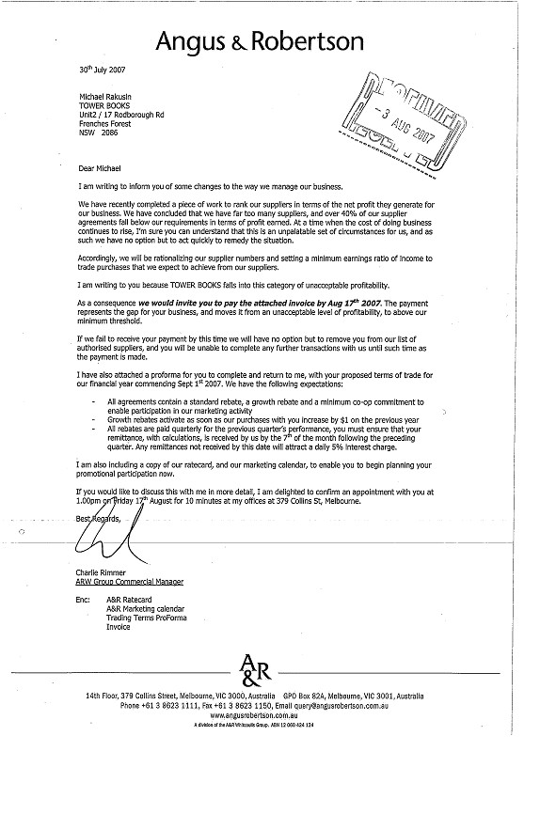
6 August 2007
Mr Charlie Rimmer
ARW Group Commercial Manager
14th Floor, 379 Collins Street,
Melbourne, VIC 3000
Dear Mr Rimmer,
We are in receipt of your letter of 30 July 2007 terminating our further supply to Angus & Robertson. As you have requested, we will cancel all Angus & Robertson Company orders on 17 August and will desist from any further supply to your stores.
I have to say that my initial response on reading your letter as to how you propose to "manage" your business in the future was one of voluble hilarity, I literally burst out laughing aloud. My second response was to note the unmitigated arrogance of your communication, I could not actually believe I was reading an official letter from Angus & Robertson on an Angus & Robertson letterhead.
My reply to you will perforce be a lengthy one. I hope you will take the trouble to read it, you may learn something. Then again, when I look at the level of real response we have had from Angus & Robertson over the past six or so years, I somehow doubt it.
The first thing I would say to you is that arrogance of the kind penned by you in your letter of 30 July is an unenviable trait in any officer of any company, no matter how important that individual thinks himself or his company, and no matter how dominant that company may be in its market sector. Business has a strange habit of moving in cycles: today's villain may be tomorrow's hero. It is quite possible to part from a business relationship in a pleasant way leaving the door open for future engagement. Sadly, in this case, you have slammed and bolted it.
More to the point, however, we have watched our business with Angus & Robertson dwindle year upon year since 2000. We had to wear the cost of sub-economic ordering from you through ownership changes, SAP installation, new management, and stock overhang. In summary, our business with you has dropped from over $1.2 million at the end of 2000 to less than $600,000 in 2007.

You would be quite correct to question whether our offering to the market had changed in any way. The answer can be derived from the fact that during the same period our business with Dymocks, Book City, QBD and Borders continued to grow in double digits, our business with your own franchise stores has grown healthily, and our overall business during the same period has grown by more than 50%.
Six years ago, we were allowed to send reps to your company stores and do stock checks. Then these were "uninvited" and we had to rely on monthly rep calls to your Buying Office. Subsequently even that was too much trouble; your Buying Office was too busy to see us, so we were asked to make new title submissions electronically. Every few months the new submission template became more and more complex. This year, we have been allowed quarterly visits to your Buying Office at which we were to be given the opportunity to sell to all your Category Managers. At the first, we did indeed see all of the Category Managers – but they didn't buy any of the titles offered. At the second, one Category Manager was available, and again no purchases resulted. At the last (only last week), two Category Managers attended. Through all of this, your overworked and under resourced Buying Department never got to see, let alone read, an actual book. While one may be forgiven for believing that Angus & Robertson is actually a company purveying "Sale" signs, I do believe you are still in the book business?
That Angus & Robertson is struggling for margin does not surprise me. It amazes me that the message has not become clear to your "management": there are only so many costs you can cut, there is only so much destiny you can put in the hands of a computer system, there are only so many ‘sweetheart’ deals you can do with large suppliers. After that, in order to prosper one actually has to know one's product and have an appropriately staffed buying department. Most importantly, one has to train sales people of competence. You will never beat the DDSs at their cost cutting game, you will only prosper by putting "books" back into Angus & Robertson. And it would seem to me paramount to stop blaming suppliers for your misfortunes, trying ever harder to squeeze them to death, and actually focus on your core incompetencies in order to redress them.
How a business that calls itself a book business is going to do without titles such as the Miles Franklin Prize winning book or titles like Rich Dad Poor Dad (according to this week's Sydney Morning Herald it is still the fifth bestselling business title in Australia nine years after publication) is beyond me. And how in good conscience Australia's self-purported largest chain of book shops proposes to exclude emerging Australian writers who are represented by the smaller distributors, is an equal mystery.
We too have expectations Mr Rimmer. We have had the same expectations for many years, none of which Angus & Robertson have been willing to deliver:
- That we are treated with equal respect to the larger publishers within the obvious parameters of commercial reality,
- That your Buying Department is able and willing to assess our books with equal seriousness to those of the big publishers and buy them appropriately,
- That you recognise the fundamental differences between the smaller distributors and the larger publishers and stop demanding of us terms that we are unable to deliver,
- That you would support and help develop Australian literature.
Had you made any effort to meet these expectations you would have found the niche we should have occupied in your business, as have all other book shops, and you would have found our contribution to the profitability of your business would have been dramatically different.
In summary, we reject out of hand this notion that somehow, even giving you 45% discount on a sale or return basis, with free freight to each of your individual stores, where we make less than half of that on the same book, puts us in the "category of unacceptable profitability". We have seen Angus & Robertson try this tactic before – about 12 years ago Angus & Robertson decided that unless we gave them a 50% discount, they would not buy from us any longer. We refused. Angus & Robertson desisted from buying from us for seven months. We survived, Angus & Robertson came back cap in hand.
We have seen Myer effectively eliminate smaller suppliers. We survived and prospered but look at the Myer Book Departments today.
We have seen David Jones decide that it had too many publishers to deal with and to exclude the smaller suppliers. We survived and prospered but look at the David Jones Book Departments today.
David Jones and Myer sell other goods; Angus & Robertson does not.
That the contents of your letter of 30 July are both immoral and unethical, I have no doubt. That they probably contravene the Trade Practices Act, I shall leave to the ACCC to determine. (Five percent interest PER DAY!!!)
If you wish to discuss any of the contents hereof, you may call my secretary for an appointment at my office in Frenchs Forest. I shall be marginally more generous than you and at least allow you to pick a convenient time.
Michael Rakusin
Director
Tower Books Pty Ltd
Carpentaria, Alexis Wright: Winner of 50th Anniversary Miles Franklin Literary Prize, 2007
Copy: Graeme Samuel, Chairman, ACCC
Rod Walker, Chairman, ARW Group
Ian Draper, ARW Group Managing Director
Rickard Gardell, Managing Director, Pacific Equity Partners
Simon Pillar, Managing Director, Pacific Equity Partners
Barbara Cullen, CEO, ABA
Maree McCaskill, CEO, APA

Posted by Susan Wyndham
August 9, 2007 11:26 AM
http://blogs.smh.com.au/entertainment/archives/undercover/014948.html
Sydney Morning Herald.

