Performance Management Policy
Purpose | The development and progress of individual employees is fundamental to John Reading’s future performance. In addition to providing the opportunities for professional development, John Readings aims to help individuals by monitoring and supporting them in their personal growth and development.  The aims of this policy are to ensure:  - Employee development opportunities are recognised and implemented efficiently and effectively  - Consistent employee development practices and principles are applied across the organisation  - Employees are developed systematically on the basis of defined needs and that development undetaken is cost-effective and meets agreed standards.
Scope | The scope of this policy covers the performance management process by employees and contractors of John Readings.
Responsibility | Responsibility for the implementation of this policy rests with managers of employees at John Readings. Further information on roles and responsibilities is discussed within this policy.
Relevant legislation | This policy is guided by the procedures set by industrial law, awards and employment agreements that apply to John Readings. Among others they include:  - Privacy Act 1988 (Cwlth)  - Anti-discrimination Act 1977 (NSW)  - Fair Work Act 2009 (Cwlth).
Updated/  authorised | 09/2019 – Damian Black (CEO)

Roles and Responsibilities
Managers will:
- Carry out biannual formal performance review discussions,
- Monitor individual performance throughout the year, recording key events, observations of importance which relate to the performance, both positive and negative,
- Refer to the performance management guidelines when carrying out tasks related to performance management,
- Use the performance management documentation to record formal and informal performance reviews,
- Provide employees with the opportunity to participate and contribute to their professional and personal development,
- Provide employees with access to training and development, as reflected in the individual’s development plan,
- Provide employees with coaching throughout the review period,
- Allow employees to communicate their career development goals, and
- Ensure employees complete their responsibilities in accordance with the performance management policy and process.
Employees will:
- Participate in the formal review discussions openly and honestly,
- Complete their personal assessment and provide it to the manager as requested,
- Contribute their thoughts on both positive and negative performance as assessed by their manager,
- Participate in identified training and development plans as agreed with their manager, and
- Provide information and documentation as requested by their manager relating to their performance and activities throughout the assessment period.
To Conduct Performance Review
The employee’s performance will be monitored and evaluated regularly throughout the year. The performance review encompasses three elements:
- An annual formal review discussion,
- A six month follow-up discussion,
- Continuous monitoring of the employee’s performance.
1. Annual Discussion
The annual discussion is a key step in the performance review process. Essentially, this step involves compiling all the information collected and assessed throughout the year relating to the employee’s performance. However, there should be no surprises in this discussion; it is merely a summary and review of the informal and formal reviews conducted throughout the year.
The key elements of the annual discussion are to:
- Reflect on performance during the year,
- Clarify key responsibilities of the role and review the job description,
- Discuss successes as well as areas for improvement,
- Set agreed targets and performance standards for the next six months,
- Agree on key areas of development for effective performance in the role.
2. Documentation
The performance review documentation is important for recording the standards, targets and development plans that are agreed upon during the performance review process. It is important to use the correct forms to maintain the integrity of the information, and to help the manager and employee ensure that the review is completed correctly.
3. Timing
Employee performance is to be formally reviewed every 12 months with a follow-up review six months into the financial year. A new plan should be completed at each annual appraisal discussion.
4. Six month follow-up discussion
The follow-up review provides an opportunity for managers and employees to re-visit targets, standards and development plans to:
- Establish that progress is on track,
- Identify changes impacting on the achievement of targets and standards,
- Discuss development plan progress or establish development plan,
- Modify standards and targets, if required.
Flow chart of the Performance Review Process
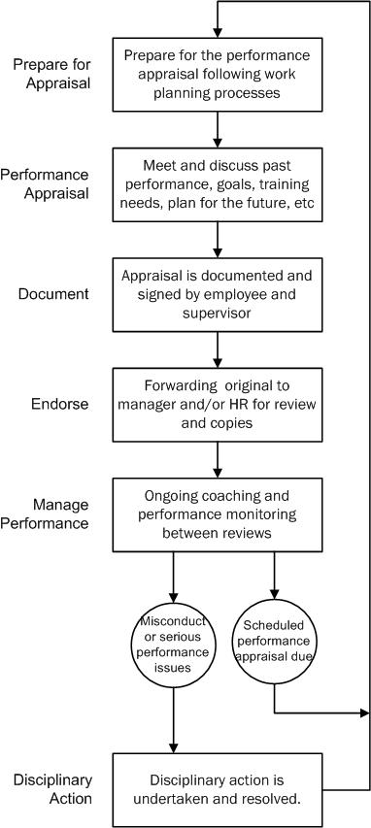

Performance Management Plan Template
Name and position:
Manager: |  |  | Review period:
Reference from operational plan | Key result area | Indicator of success/ performance |  |  | By when | Status report
Achievements: |  |  |  | Areas of Opportunity:
Manager’s comments:
Signature: Click or tap here to enter text. |  |  |  | Date:
Staff member’s comments:
Signature: Click or tap here to enter text. |  |  |  | Date:

