John Readings Partnerships that Raise the Bar
Communication to Suppliers
John Readings is committed to attracting and competing for suppliers that provide us with high quality and innovative products, when we need them, at competitive pricing and advantaged terms from all across the world. Such suppliers enable the company to exceed the expectations of our own customers, delivering significant and tangible value resulting in our growth.
We intend to do business only with suppliers that subscribe to our philosophy of quality and competitiveness and who will collaborate with us to help insure we enjoy an advantage in our marketplaces. John Readings recognises that a supply base that can meet the requirements stated above enables our growth, and in return we will reward that supply base with the opportunity to grow along with us.
John Readings purchasing philosophy is built on the following four key elements:
- Quality. Suppliers must meet or exceed defined requirements,
- Productivity. Total cost savings must be delivered year-over-year,
- Advantaged terms. Suppliers to our corporation accept our standard terms of payment,
- Lean manufacturing. There is a relentless focus on cycle-time and inventory reduction to benefit both of us.
John Readings will clearly articulate its requirements to all suppliers, insuring that the playing field is level. As a result, we expect to receive highest value for every dollar we spend.
The Global Groups that make up our company (retail shops and online) represent a significant potential opportunity for suppliers that want to engage with us and subscribe to our philosophy. Our purchasing operations are committed to promoting synergy across the corporation, and if you become a supplier in good standing and can support the requirements of our groups, you may then be syndicated as a strategic partner across our enterprise. The potential herein is sizable!
We welcome you to learn more about John Readings, and we invite you to contact us for consideration as a potential supplier.
How We Buy
We seek world-class suppliers that are capable of providing a diverse range of goods and services meeting our corporate-wide requirements in line with our expansion strategy.
Potential suppliers will be considered for use based on their product or services offered, after an assessment by a cross-functional team yielding a favourable rating, and, after the supplier agrees to our Focus 5 minimum requirements. For more information about the Focus 5, see details below.
John Readings purchasing operations is harnessing the Internet as its preferred process for collecting pricing information from its suppliers, and suppliers will be expected to have advanced Internet connectivity and navigation skills. Suppliers will be required to respond to pricing inquiries and process orders via the Internet.

John Readings has placed the following ‘RF’ processes online:
- RFI – Requests for Information,
- RFP – Requests for Proposal,
- RFQ – Requests for Quotation.
Direct material suppliers to the company may be required, depending on business processes, to support EDI (Electronic Data Interchange) order/acknowledgment/invoicing or other EDI processes. Suppliers that are EDI capable may receive preferential treatment when being evaluated for possible use by John Readings.
Suppliers of indirect goods and services may be required to participate in an online order process involving development, publishing, and maintaining online electronic and specialist catalogues specifically for the company. Suppliers that are capable of supporting this technological requirement may receive preferential treatment when being evaluated for possible use by John Readings.

What We Require of Our Suppliers
Our Focus 5 – The baseline requirements of suppliers doing business with us.
1. Productivity
A minimum of five percent per year, every year.
Annual productivity is the cornerstone of our strategic supplier partnerships and requires a commitment from your company to ensure the metric is achieved. A subscription to the philosophy of year-over-year productivity is required. Commitment to this initiative fuels our ability to be competitive in our marketplace and helps insure continued business growth - both yours and ours. This objective requires creative thought and input of our suppliers, working closely with our purchasing departments, who can facilitate interface to our marketing department.
2. Advantaged Payment Terms
Terms of payment are determined on a department basis, however, any supplier to any John Readings will be expected to adhere to a minimum of 2% 60, net 90 as a baseline condition of doing business. Departments will, from time-to-time, seek more aggressive terms or terms more appropriate to their buy. Terms extended to one department or group will be assumed to apply to any other dept. that subsequently is engaged by the supplier.

3. Quality
Six Sigma quality is our goal.
John Readings publishing portfolio is one of the most recognised and admired in the world. Your company's support and focus on product quality should be relentless. Our Sourcing and Quality Teams will work with resources within your company to drive root cause analysis and corrective action processes. This partnership and commitment will help insure you meet our quality requirements.
4. Lead-Time
14 days or less for all popular goods/services.
Supplier lead-time at John Readings is measured as the total number of days between Release Of Order/Schedule and the Receipt Of Goods (ROOROG) at our warehouse facility or distribution centre. Lead-time is inclusive of our supplier's manufacturing cycle time and the transit time for product to get into our facilities.
We are open to discussing supplier-owned inventory within our warehouses and distribution centres as a way helping you to reach our lead-time goal.
5. Service Level
On-time delivery is a window of plus (+) two days minus (-) zero days of an actual schedule date.
Our customers demand that goods be delivered to meet their just-in-time requirements. As a result, we must demand similar performance from our suppliers.
Are you ready to do business with us?
These "Focus 5" expectations are entry-level requirements of all suppliers to do business with John Readings. They may seem aggressive, but read on to learn what's in it for you".
What's in it for you?
As a rapidly growing and globally expanding company, we have clearly stated objectives in terms of annual growth. The potential impact to our strategic suppliers and the extrapolation is simple: If we're growing, you're growing!
You can materially impact our collective growth by participating in the Focus 5 initiatives outlined in "What We Require of Our Suppliers" and the benefit of being a syndicated strategic partner to our company can open an enormous market for your products, goods, and services!
New products are also a key to our growth, and as a strategic supplier, we request that you continuously provide new product ideas or promotional pricing to John Readings. Bringing new product ideas and concepts to John Readings is critical to collectively growing our organisations in a sustainable and profitable manner.
The purchasing operations, and in particular our COE's, have a supplier stratification methodology that is employed to rank and rate our suppliers. The ranking system is a three-tier process used to classify our suppliers:
Category 1: Strategic Partner,
Category 2: Supplier/Vendor,
Category 3: New Supplier, or Supplier at Risk.
Our goal as a company is to cultivate strategic partners for over 80% of our total spend. It will be our plan to grow all new suppliers into Category 1 or (at a minimum) Category 2 Suppliers. We will proactively weed Category 3 Suppliers from our business.
Category 1: Strategic Partners will be syndicated as preferred suppliers across all areas of the business. Those suppliers achieving this designation could be supporting many of our strategic and new growth business requirements and thus enjoy significant potential growth as a result.
By eliminating Category 3 Suppliers (Risk), John Readings insures only the most capable of suppliers are supporting its business, and we strategically "right-size" our supply base to a level appropriate for support of our customers.
How We Select Our Suppliers
New Supplier Assessment and Qualification Process
All potential suppliers will be assessed utilising a standardised process through the use of our Supplier Assessment Tool. You can access this tool on our website.
The aim of our assessment process is to allow an assessment team to get a comprehensive, constructive and objective view of the supply base.
Choosing the right supplier from the start, with integral cost in mind at the beginning of new project activities, is essential to insure that the long term supply of products at the right price, quality and service levels.
How We Use the Assessment Tool
The aim of this supplier assessment tool is to estimate the total quality environment of the supplier - vision and alignment of resources, focus-five ability, quality systems and continuous improvement as well as process control and improvement. The assessor, using our tool, will look at product development capability, financial well-being of the company, ethical business practices and competitive concerns as well.
The tool is designed to be detailed enough to allow for consistent results from a large number of assessors in the same environment. All our purchasing team has had appropriate training to ensure that the tool produces consistent and objective conclusions.
Criteria in the score sheets are weighted according to importance to finding the right suppliers and there is, in theory, no minimum score of acceptance or failure for suppliers assessed with our tool.

The Results
The assessment tool in itself offers a roadmap to excellence for suppliers. Our Purchasing department follows a plan/do/check/act process for supplier improvement action plans and follow up audits.
How We Develop and Measure Supplier Performance
The Supplier Development and Scorecard process at John Readings helps to insure that the purchasing team can identify, qualify, monitor, and reward its supplier base. The main components to this program are:
- Assess and qualify,
- Measure and scorecard,
- Rate and recognise.
We call this our "5-Step Supplier Development Process".
This tool helps to insure that we have a developed supply base that can help us compete for our unshared fair of business with our own customers.
This methodology also will help to insure that we can compete for capacity at the declining number of world-class suppliers in our global market.

The following pages document the overall rating process, the scoring methodology, the supplier categorisation process, and our award process for those suppliers who become eligible. As part of our ongoing relationship, it is important for both of our organisations to communicate effectively with each other. Accordingly, we would like to introduce the John Readings Supplier Performance Scorecard (SPS). The purpose of the SPS is to give suppliers timely feedback on their performance as a supplier to our organisation.
A Supplier's SPS rating will be based upon four specific performance criteria or metrics in the areas of quality, service level, productivity, and responsiveness. Each of these ratings, with the exception of responsiveness, will be attributable to specific fact-based metrics of your organisation’s performance. The ratings for each of these aspects are weighted equally at 25% of your overall SPS Score, which then drives your categorisation as a Category 1, 2, or 3 supplier of John Readings.

The chart below summarises the overall SPS Score, the Supplier Category Rating, and the associated commercial response John Readings will pursue.
SPS Score | Supplier Category | Commercial Action.
16 and above | Category 1  Strategic Partner | Pursue long-term Business Agreement Channel future growth opportunities to supplier.
8 - 15 | Category 2  Supplier/Vendor | Supplier performs as required and has potential to improve to Category 1 supplier.
< 8 | Category 3  New/Risk | A new supplier needs development to min Category 2. If current supplier, no new business will be awarded to and alternative sourcing may be considered.
To read more about how John Readings classifies its supply base, including the potential benefits of being a Category 1, 2, or 3 supplier, please see below.
We will communicate the Supplier Performance Scorecard on a quarterly basis as soon as practical after the close of each calendar quarter. We encourage and solicit our supplier's feedback on their SPS score and category rating, and are more than willing to meet on a quarterly basis to discuss.
The following pages will set forth in detail the associated metrics, calculations, and ratings for each of your performance criteria.

Scale
Observed/Reported DPPM | POINTS
0 - 3,600 | 5
3,601 - 5,000 | 4
5,001 - 7,000 | 3
7,001 - 10,000 | 2
10,001 - 20,000 | 1
> 20,000 | 0
The Supplier Scorecard Process
Quality
Definition: Adherence to defined specifications.
Performance Metric: Defective Parts Per Million (DPPM).
DPPM Calculation: = Number of part defects / number of parts shipped x 1,000,000.
Overall Rating Impact Percentage |  | 25%

Scale
Shipment % | POINTS
100% | 5
99 - 99.9% | 4
98 - 98.9% | 3
97 - 97.9% | 2
95 - 96.9% | 1
< 95.0% | 0
The Supplier Scorecard Process
Service Level
Definition: On-time shipment to request date in a window defined as zero (0) days late and no more than two (2) days early.
Performance Metric: Percentage of orders shipped to our request date.
Calculation: ‘Number of ordered line items shipped on time’ dividing by ‘total number of line items requested’.
Overall Rating Impact Percentage 25%

Scale
Cost Reduction Percentage | POINTS
> 10% | 5
> 5.1 - 10% | 4
> 4.1 - 5% | 3
> 3.1 - 4% | 2
> 0.0 - 3% | 1
< 0.0 | 0
The Supplier Scorecard Process
Productivity
Definition: Year-over-year total cost reduction.
Performance Metric: total cost reduction percentage.
Calculation: Total Cost Reduction / Total Purchase Costs.

Bonus points will be granted for every one percent over 10 percent, up to eight points maximum.
To achieve bonus points, the supplier must have a minimum quality score of two points.
Two points will be deducted for every one percent cost increase.
Overall Rating Impact Percentage 25%

Scale
Subjective Value | POINTS
Extremely Cooperative Conduct | 5
Very Cooperative Conduct | 4
Acceptable Conduct | 3
Marginally Acceptable Conduct | 2
Poor Conduct | 1
Unacceptable Conduct | 0
The Supplier Scorecard Process
Responsiveness
Definition: Subjective rating issued by purchasing personnel. Ratings will be based upon meeting our expectations and may include but are not limited to the following:
- Lead time improvement,
- Responsiveness to corrective actions,
- Product development and implementation,
- Emergency orders inside agreed lead times,
- Compliance to Irwin requested payment terms,
- Commercial relationship within the context of supply agreement,
- Overall supplier/customer relationship.
Performance Metric: Subjective Rating

C.O.S.T: John Readings Collaborative Online Savings Tool
The partnerships John Readings seeks to forge with its suppliers are intended to bring benefits to both parties, and this is especially true in the areas of cost reduction.
We have ideas of how costs can be reduced on both sides of the equation, and we share those ideas with our strategic partners - from alternative material utilisation, improved specifications, and design for manufacturability reviews, to lean manufacturing techniques we've learned and use, inventory and cycle-time reduction ideas, and value analysis programs.
But the most powerful ideas for savings often come from our suppliers. This is why we have developed C.O.S.T. - the John Readings Collaborative Online Savings Tool.
C.O.S.T. is a formal savings ideas submission, review, collaboration, approval, and implementation process. Supplier submissions through this process will become a metric John Readings will use to enhance its supplier measurement program.
C.O.S.T. is a web-based, simple for our partners to use, and available worldwide on a 24 x 7 basis.
C.O.S.T. - Collaborative Online Savings Tool!

The Supplier Connection
Strategic partners deserve strategic benefits, and the John Readings Supplier Connection is just such a process. Born out of a desire to make doing business with us easier, The Supplier Connection is an online process that is available to our Category 1 Strategic Partners and our Category 2 Suppliers/Vendors.
Through this online supplier portal, our strategic partners can access such valuable information as:
- Forecast information,
- Required shipping schedules,
- Open purchase orders for your company,
- John Readings and department/team specific news and information.
If you are an approved and registered supplier with John Readings, you can access the Company Supplier Connection Portal.
The Supplier Connection is a tool to make doing business with John Readings smarter and faster. More information about that Supplier Connection can be learned by registering through the contact us process on this site.
To access the Global Supplier Report Card Process (GSSI), log into the Company Supplier Connection Portal.

Our Supplier Quality Assurance Program
Our requirements for supplier quality performance have not been developed without considering how we can assist our suppliers in achieving the goals and expectations we have set forth. John Readings has a comprehensive Supplier Quality Assurance program that has been built around facilitating world-class quality from the suppliers we partner with.
Our Supplier Quality Program sets forth baseline requirements for quality systems and processes at our suppliers, including key measurement criteria, required closed-loop corrective action, and basic reporting requirements.
If you are a supplier today that has similar tools and processes already in place, then you may meet the basic quality systems requirements for doing business with John Readings. If you do not have as robust a process in place, then these tools may help you become a supplier capable of doing business with us in the future.

Useful Documents Worth Reading
To read more about our Supplier Quality Assurance program, you may download the following related documents:
- Supplier Quality Assurance Manual,
- Supplier Assessment Survey,
- First Article Inspection Checklist,
- First Article Report,
- Control Plan Template,
- Supplier Process Change Request,
- Corrective Action Report,
- C=0 Sampling Plan,
- To view your current Online Supplier Report Card, login to the company supplier portal.

John Readings Strategic Partner Program
How We Develop and Measure Supplier Performance
The Supplier Development and Scorecard process at John Readings helps to ensure that the purchasing organisations can identify, qualify, monitor, and reward its supplier base. The main components to this program are:
- Assess and Qualify,
- Measure and Scorecard,
- Rate and Recognise.
We call this our "5-Step Supplier Development Process". This tool helps to ensure that we have a developed supply base that can help us compete for our fair share of business with our own customers.
This methodology also will help to insure that we can compete for capacity at the declining number of world-class suppliers in our global market.
The following pages document the overall rating process, the scoring methodology, the supplier categorisation process, and our award process for those suppliers who become eligible. As part of our ongoing relationship with our preferred suppliers, it is important for to communicate effectively with each other. Accordingly, we would like to introduce the John Readings Supplier Performance Scorecard (SPS). The purpose of the SPS is to give suppliers timely feedback on their performance as a supplier to our organisation.
A supplier's SPS rating will be based upon four specific performance criteria or metrics in the areas of quality, service level, productivity, and responsiveness. Each of these ratings, with the exception of responsiveness, will be attributable to specific fact-based metrics of your organisation's performance. The ratings for each of these aspects are weighted equally at 25% of your overall SPS Score, which then drives your categorisation as a Category 1, 2, or 3 supplier of John Readings.
The following chart summarises the overall SPS Score, the supplier category rating, and the associated commercial response John Readings will pursue.
SPS Score | Supplier Category | Commercial Action
16 and above | Category 1: Strategic Partner | Pursue long-term business agreement; channel future growth opportunities to supplier with potential to develop alliance relationship.
8 – 15 | Category 2: Supplier/Vendor | Supplier performs as required as has potential to improve to Category 1 supplier.
Less than 8 | Category 3: New/Risk | A new supplier needs development to move to category 2; if current supplier, no new business will be awarded and alternative sourcing may be considered.
We will communicate the Supplier Performance Scorecard in a reasonable time after the close of each calendar quarter. We encourage and solicit our supplier's feedback on their SPS score and category rating, and are more than willing to meet on a quarterly basis to discuss.

John Readings Strategic Partner Program - Criteria and Opportunity
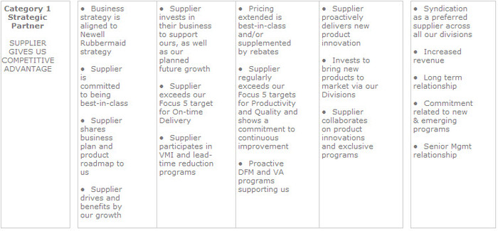
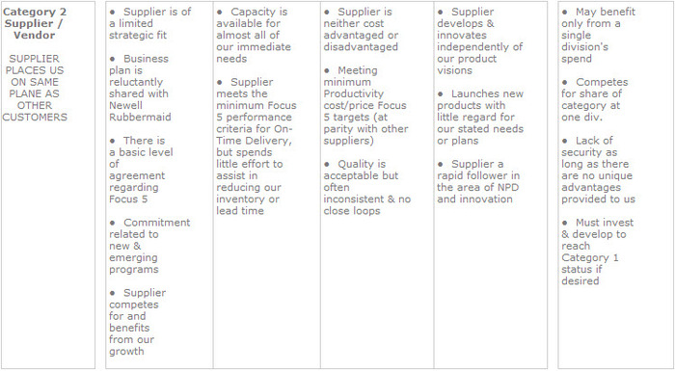
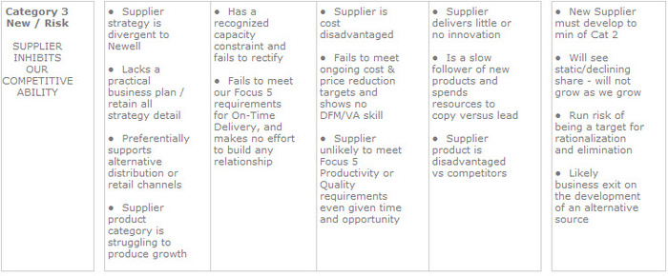

Diversity and Inclusion
John Readings has long been a workplace that places high value on a diversity of functions, teams, processes and qualities and includes every individual to help drive business success. This means we have to leverage the true power of diversity by embedding it in our practices. We listen to a broad cross-section of our workforce. Diversity of thought and perspective from our talent base, functions and teams strengthens our ability to respond to increasingly global and varied socioeconomic consumers.
We need people who can see the world through the lens of our prospective consumers in markets where we anticipate growth. This happens most easily when people who have worked and lived in those markets use their perspective to develop plans and inform their colleagues’ perspectives.
Internally, we have six employee resource groups (ERGs) to continue developing our inclusion, diversity and global readiness agenda through employee input and feedback.

Supplier Diversity
Diversity at John Readings extends to our supply chain. Partnering with a diverse set of suppliers enables us to better understand our global and diverse consumer base. Our worldwide supplier diversity practices are designed to provide a fair chance to participate in outsourced John Readings projects.
We are an equal opportunity employer and extend this to all supplier relationships. We actively support new business enterprises for people over 50 and mother’s re-entering the work environment.
We also look for suppliers who echo our corporate values by demonstrating a sharp eye for product innovation; displaying an ability to collaborate; offering best-in-class prices, quality and service; and making constant investments that improve people, processes, product and safety. To learn more about partnering with John Readings, please go to the section on supplier performance.
Business Ethics
John Readings is committed to the highest standards of ethical conduct in all of our business dealings. Our relationship with our suppliers ensures that all businesses have fair and equitable opportunity to participate in any outsourced John Readings projects. We are committed to ethical practices that ultimately contribute to our ability to provide innovative, quality products to our consumers and grow our brands that matter.
We invite all suppliers to compete for our business, and in return, suppliers can expect a level playing field. We have no hidden factors in evaluating suppliers and submitted proposals – all relevant decision criteria will be spelled out in advance of soliciting a proposal.
Our employees are prohibited from accepting gifts or gratuities from our suppliers. While our rules do allow for limited exceptions for items of nominal value, the offer or acceptance of gifts is inappropriate and discouraged. Under no circumstances will our employees solicit any gift or gratuity.
John Readings reserves the right to reject any and all proposals and does not bind itself to accept the lowest bid for any materials, products or services submitted. Non-acceptance of any proposal will not imply any criticism of or deficiency in any proposal. Non-acceptance will mean that another approach was deemed by John Readings to be more advantageous.

Ethical Standards Manual
Our Ethical Standards Manual and associated processes are in place to allow our partnership with suppliers to be one of fairness and trust. Our program is based upon John Readings Code of Business Conduct and Ethics and Supplier Code of Conduct along with the requirements of our customers' Ethical Standards.
These standards for suppliers cover many areas: child labour, forced labour, environmental, health and safety, discrimination, harassment and abuse, working hours, workers’ compensation, freedom of association and collective bargaining, access for assessments and a set of general requirements. The associated assessment and assessment program covers these areas in greater detail and are addressed in the manual.
In addition to meeting the requirements of John Reading’s Supplier Code of Conduct and the requirements of our customers, the Ethical Standards Manual and associated processes intend to improve the quality of life of the workers that make the merchandise we supply, comply with legal requirements and global ethical business practices, and insure business processes are in place that comply with the supplier code of conduct.

