PM Solutions/Courses
COURSE/PROGRAM LOGOS
PM Essentials 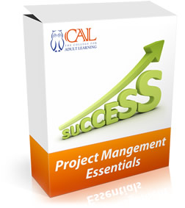

MS Project 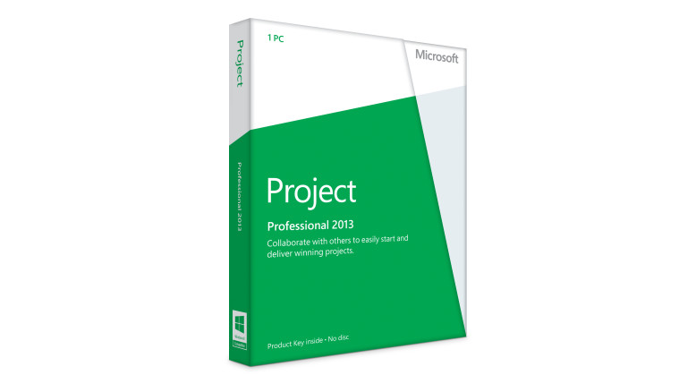

Certificate IV in Project Management Practice

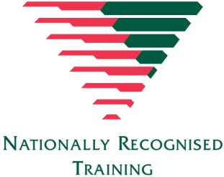

Diploma of Project Management
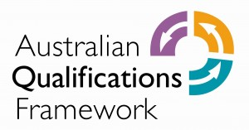

PRINCE2 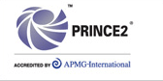

Agile 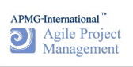

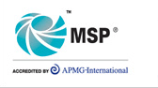

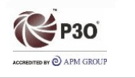

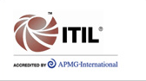

Adaptive Frameworks is one of the most successful providers of Project Management and Program Management expertise in Australia offering a range of PRINCE2 and related global certifications to clients. Health checks, maturity assessments, planning workshops, establishing appropriate project management guidelines or templates, setting up project management offices, dealing with change or any of a number of specialist project management activities are all within our capability.
TMA

